Output of ColorImage.cpp:


Original image

Picture contains only the red channel.
Red

Picture contains only the green channel.
Green

Picture contains only the blue channel.
Blue

Picture indicates the luminance.
Y

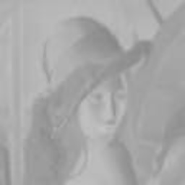Picture indicates the blue difference chroma components.
Cb

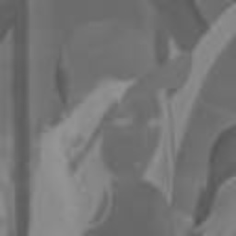Picture indicates the red difference chroma components.
Cr

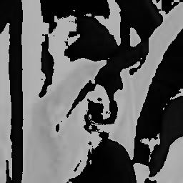Picture indicates the color by angle (no idea why it’s black and white)
Hue

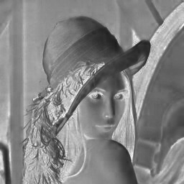Picture indicates the percentage of gray in each pixel, so it’s black and white.
Saturation

Picture indicates the brightness. (black and white)
Value

